STEP:1 download log4j and slf4j jar file from jav2s.com

Log4j: <http://www.java2s.com/Code/Jar/l/Downloadlog4jjar.htm>

Slf4j: <http://www.java2s.com/Code/Jar/s/Downloadslf4jjar.htm>

Extract both the zip and add it to your app

STEP:2 open any Webdynamic project

Src>main>webapp>WEB-INF>lib>copy both files

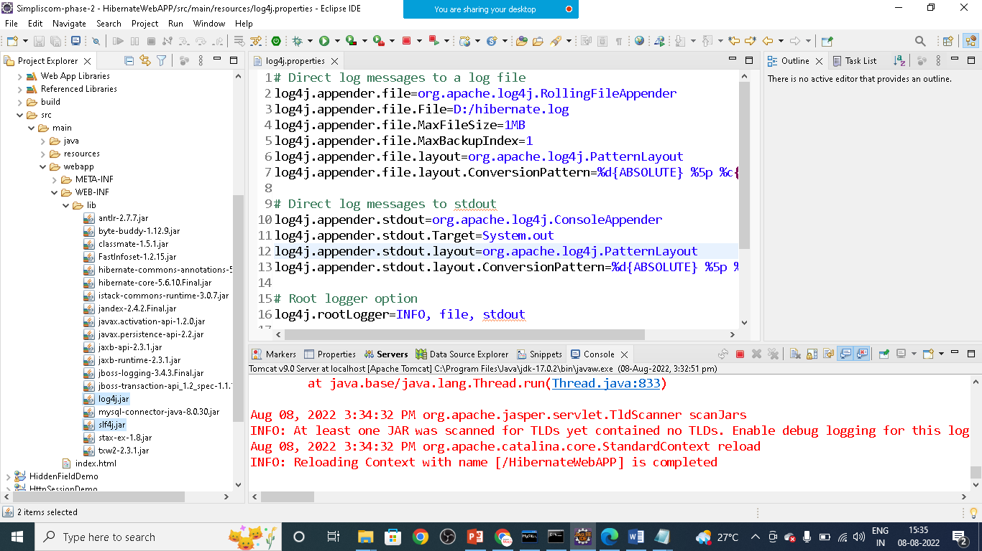

STEP:2 GOTO> RESOURCE FOLDER AND CREATE log4j.properties file

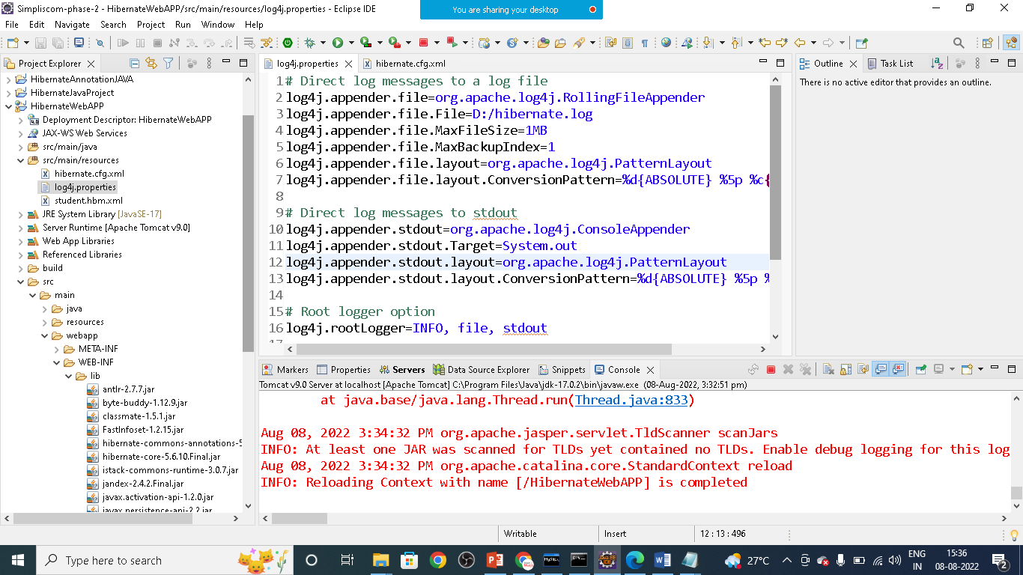

Add below code

# Direct log messages to a log file

log4j.appender.file=org.apache.log4j.RollingFileAppender

log4j.appender.file.File=D:/hibernate.log

log4j.appender.file.MaxFileSize=1MB

log4j.appender.file.MaxBackupIndex=1

log4j.appender.file.layout=org.apache.log4j.PatternLayout

log4j.appender.file.layout.ConversionPattern=%d{ABSOLUTE} %5p %c{1}:%L - %m%n

# Direct log messages to stdout

log4j.appender.**stdout**=org.apache.log4j.ConsoleAppender

log4j.appender.**stdout**.Target=System.out

log4j.appender.**stdout**.layout=org.apache.log4j.PatternLayout

log4j.appender.**stdout**.layout.ConversionPattern=%d{ABSOLUTE} %5p %c{1}:%L - %m%n

# Root logger option

log4j.rootLogger=INFO, file, **stdout**

# Log everything. Good for troubleshooting

log4j.logger.org.hibernate=INFO

# Log all JDBC parameters

log4j.logger.org.hibernate.type=ALL

Save it and run the project again

